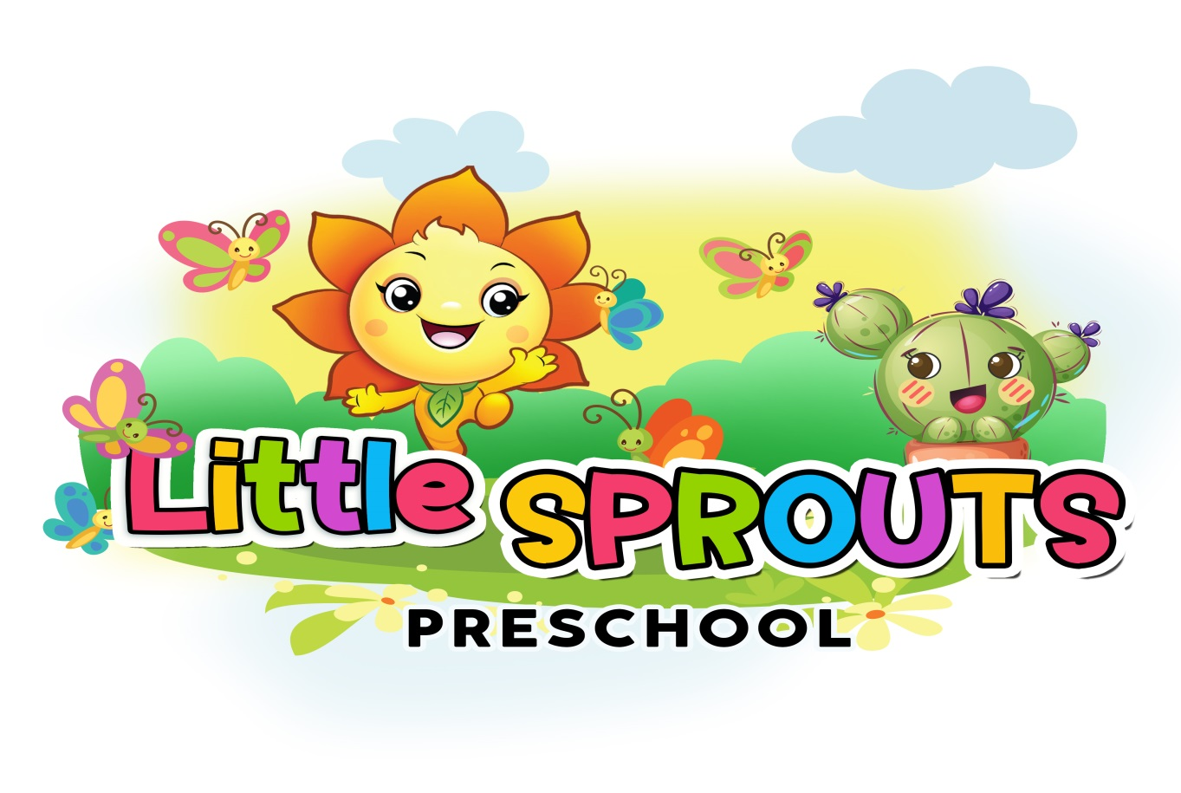
Parent Handbook

Phone: 423-698-2901 Phone: 423-708-8327
Address: 2001 Raulston St. Address: 12 Sequoia Dr.
Chattanooga TN. 37406 Chattanooga TN. 37411
Email: littlesproutsps1.2@gmail.com Email: littlesproutsps1.2@gmail.com
Table of Contents

3 | Welcome | 8 | Daily Schedule
 | Program Philosophy |  | Infant/Toddler Care
 | Hours of Operation |  | SIDS
 | Staff-to-Child Ratios |  | Infant Feeding
 | Parent Access to Children During Care |  | Diapering
 | Arrivals and Departures |  | Potty Training
 | Alternate Care | 9 | Guidance and Discipline Policy
5 | Closures/Holidays |  | Religious Activities
 | Child Absence | 10 | Holidays
 | Enrollment Process |  | Provider Absence
 | Trial Period |  | Mandatory Reporting
 | Termination of Care |  | Health and Emergency Preparedness
 | Child Records |  | Immunization Tracking
6 | Communication Plan |  | Removal of Ill Persons Policy
 | Rates, Fees, and Payment | 11 | Emergency and Evacuation Plans
 | Parent Supplied Items
7 | Food Service Practices
 | Napping/Sleeping

Welcome:
Welcome to the family! I am Shemika Copeland, Owner/ Executive Director. I have two kids of my own 10 years apart. In my spare time I practice real estate. I’ve been in the daycare business over 20 years. I’ve owned my own facility for 13 years now. I love to cook, and the smiles on the kids face when exploring something new. The early part of owning my own business, I went back to school at night for Child Development at Chattanooga State. I accept certificates for families that need assistance paying for their child’s care. I’m so excited that you’ve chose to have your little ones be a part of our family. Can’t wait to get those curious minds moving!
Program Philosophy:
Each child should be giving enough individual attention to help them feel comfortable with their child care provider. Children should be exposed to a group environment where he can interact with other children and learn the very necessary social skills that she will need as they progress into the elementary environment. We seek to stimulate the child’s curiosity, and encourage well-rounded growth for all children based on their individual levels of development. We strive to prepare children to look forward to “BIG KID School.”
Hours of Operation:
7am. - 5pm. 2pm-11pm A Dollar a Minute Any Time After
Job/School schedule- If you work or in school I’m willing to work with your schedule. You have thirty min. before and thirty min. after to come if it’s more than 8hour shifts. Have your child here before 9am to eat breakfast and cut off time for morning care. Any time after if not discussed will be a late charge which is a dollar a min. up until 9:30am. After 9:30am if not discuss your child will not be accepted that day. Your weekly payment or certificate only pays for 9 hours a day if not discussed before enrollment.
Staff-to-Child Ratios:
Ratio is very important in the care of our kids. We have to make sure we have enough staff to cover shifts to make sure the day runs smoothly. To make sure of that cut off times are in place.

Parent Access to Children during Care:
Volunteering is welcomed in our facility. Let me know ahead of time you would like to help out rather its reading to the kids, preparing and eating lunch, are on the playground we welcome you. Let’s have the conversation first because sometimes staying after drop off, pick up or during the
day affects children’s behavior. **These events will be postponed until further notice due to COVID-19
Arrivals and Departures:
Arrival- Little Sprouts Preschool opens at 7:00am daily. After 9:30pm the door will be locked until 3:00pm. We ask all parents to have their child in school by 9:00am so that your child does not miss breakfast or the lesson for the day. Upon arrival to the classroom, it is the parent’s duty to sign in their child(ren) on the Brightwheel App using our tablet or your phone. If your child will be absent for the day, please call the office or send a message notifying your child’s teacher by 9:00am. Please do not bring your child in his Sunday best. Getting dirty is a must to have a great fun filled day! Please do not let your child bring in any Food, Toys or Guns. Doing so only upsets the other kids and sharing is what we strongly encourage here.
Departure- The door will re-open at 3:00pm for parents to pick up their children, please sign your child out using your 4-digit code on the tablet or phone. If someone new is picking up your child in the afternoon, parents must notify the teacher and/or the owners. We will check ID’s upon their arrival.
Late Pick Up- We close promptly at 5:00pm/11:00pm, parents/guardians will be charged $1 per minute after 5:00pm/11:00pm, so please make sure you arrive on time! Continuous late pick up can result in removal of the child.
Alternate Care:
In the event that the daycare is closed it is the parents’ responsibility to find alternate care. It is also a good idea to have alternate care for in case their child is too ill and cannot attend daycare.

Closures/Paid Holidays:
The center will be closed for all Government Holidays except Veteran’s Day. Instead we take two days for Thanksgiving Day and the day after. We follow Hamilton Counties School closings except for flooding we follow regular schedule.
New Year’s Day Memorial Day Thanksgiving Day & Day after
Close at 2:30
Good Friday Labor Day Christmas Eve & Day
July 4th Christmas Day Presidents Day
When these holidays fall on a weekend, I’ll take either the Friday before or Monday after as the paid holiday.
Each year we will close for two weeks for provider’s vacation time. I’ve never in the 13 years I’ve been open used all 14 days and I usually take a Monday and Friday because I realize the inconvenience it would be to take them all together. You will receive at least a two week notice of the closing days.
Child Absence:
A leave of absence will be granted due to a work lay-off, loss of job or maternity leave. If a child is absent from daycare, you can pay a minimum fee of $75 per week to hold the position open for up to six weeks. After six weeks, the rate will return to the full amount or I will need to fill the vacancy with another child.
Enrollment Process:
Detail enrollment criteria. List any forms that will need to be returned prior to or on the first day of care such as:
- Enrollment form
- Immunization records
- Parent/Provider contract signed and dated
- Handbook/policy agreement form
- Transportation authorization
- Food program enrollment form
- Enrollment fee
- First weeks payment
Trial Period:
I do not discriminate in admissions based on race, creed, color, religion, sex or national origin. I do, however, recognize that not every child will fit comfortably here. For this reason, every new child begins on a two week trial basis. During this time, the parents or the provider are allowed to give a one day notice to terminate care on the basis of not being a “good fit.” After the trial period a two week notice is required for either party to terminate care.
Termination of Care:
I have the right to terminate care immediately or at any time for reasons including, but not limited to: failure to pay fees on time, failure to comply with policies, failure to comply with agreed upon pick up times, and/or lack of parental co-operation and respect.
Child Records:
I am required by the Department of Human Services Licensing to keep records for 5 years. Please notify me of any updates as they occur. Information regarding your family is kept private except for the reporting I must do to my licensing agent. I am also required to report by Tennessee law to report any suspected cases of child abuse to Social Services. This includes physical, emotional, and sexual abuse, as well as neglect.
Communication Plan: Little Sprouts Preschool uses an app system called Brightwheel! This is an app that parents will download onto their phones in order to receive messages, pictures, and see what their child is learning about each day. Each teacher has a tablet in the classroom in which parents will sign their child in and out using a 4-digit code that is sent upon enrollment. All friends or family members permitted to pick up your child will be added to your child’s profile within the app. This is our main source of communication between staff members and parents! If you need to contact in another way please use: Office Phone-423-708-8327.
Rates, Fees and Payment:
Enrollment Fees: $50.00 Enrollment Fee this due before the first day of care.
Holding Fee: $75.00 Keep your child’s spot while she’s out/Waiting List
Late Fees: $1.00 a minute is due the following day
Bills and Receipts: Tax receipts will go out January 31st, receipts for weekly payment given on Fridays
Payment Due: Weekly fees are due on/by Monday morning. $5.00 a day will be added to your account their after. Weekly fees are due regardless of your child’s attendance, (vacation, illness, etc.) Our operation costs remain the same when children are absent and we cannot absorb this expense. You have two weeks for payment to become current or you will be terminated.
Art/craft fee: $25 due on April 1st and October 1st
Payment Forms: Payment should be in the form of Pay Online, Cash, Money Orders is acceptable. No checks!
Parent Supplied Items:
Parents supply clothing, diapers, wipes, formula.
Toys/Items Form Home:
ARE NOT ALLOWED!
Food Service Practices:
Your child will be enrolled in the Child Care Food Program. This is a federally funded program and insures that your child will be served nutritionally balanced meals. Meals will be served at the following times:
Breakfast: 9:00am Lunch: 12:00pm Snack: 3:00pm
Second Shift
Snack: 3:00pm Dinner: 6:00pm Snack: 9:00pm
A child will be expected to eat what is severed for each meal. If they dislike an item, they will be encouraged to taste it, but no alternatives will be severed. Food allergies should be addressed during enrollment and posted so all staff is aware. Parents can bring an alternate food for the ones with allergies or doctor written excuse as to why that child can’t have it. Staff will sit with all children being served and have small talk, encouraging the picky eaters to try new foods, and assisting with them feeding themselves. Birthday parties will be the second Friday for each month for all children in that classroom.

Napping/Sleeping:
Nap is from 12pm to 2:30pm. Children that are not sleepy can find a quiet activity or read a book till nap is over. Babies sleep in a baby bed and on their backs. Children over 12 months sleep on a mat.
Daily Schedule:
7:00 | Daycare Opens – free play
9:00 | Breakfast
9:30 | Preschool Activities – circle time, crafts, music, stories
9:55 | Outside
10:55 | Free play
11:35 | Art
12:00 | Lunch
12:30 | Nap/Rest Time, quiet play for non-sleepers, kid’s movie may be available
2:30 | Quiet Play – Puzzles, play-dough, reading
3:00 | Snack
3:30 | Outdoor play, large group activities
4:30 | Clean up
5:00 | Daycare close for first shift
Daily Schedule Second Shift: | 2:00 Free Play/Outside  3:00 Snack  4:00 Homework/Outside/Free play  6:00 Dinner  8:00 Quiet Play- Puzzles, Play-dough reading  9:00 Snack  11:00 Daycare Closed

Diapers and Potty Training: At Little Sprouts Preschool, we change diapers a minimum of four times daily for children over the age of one. The diapers of infant students are checked once an hour. It is required of the parents to provide the appropriate amount of diapers for your child on any given day. Teachers will notify parents when your child’s diaper supply is running low. All diapers and pull-ups MUST have Velcro strips on the side, please do not bring pull-ups that only slide up and down.
I feel most children are ready to begin potty training when they turn two years old. This is something we should discuss between us, since consistency between here and home will be very important. Dressing your child in one-piece outfits such as overalls and onesies or using pants with difficult snaps and belts will cause frustration showing them how to pull their clothes down on their own. Please take into consideration each morning during the potty training process. Be sure to provide me with several extra clothes in case of accidents.
Consent Form- If you desire for Little Sprouts staff to apply diaper cream or ointment, bug spray, or sunscreen we need the parent to fill out a consent form or provide a written letter of permission to place in your child’s file. This form will require you to indicate which you would like staff to apply, when, and how.
Guidance and Discipline Policy:
At Copeland’s Child Care we believe that discipline should be used to teach the child and help him learn to make good choices. We take the time to explain the rules of the daycare frequently and in a way that is developmentally appropriate for the child so that she may understand what is expected of her. Once a child understands the daycare rules the following techniques are used to guide behavior.

Positive Guidance Techniques:
- Ignoring - Some negative behavior is produced by a child to get attention. It can be stopped when it does not get the attention desired. We will use this technique unless a safety issue is involved.
- Redirection - We offer alternatives to children engaged in undesirable behavior by presenting a different toy or activity.
- Verbal Intervention - We explain to the child the inappropriate behavior and show him the appropriate way to handle the situation with words.
- Logical Consequences - We help the child understand the logical consequence of her actions by removing the object or activity in which the child is engaged.
- Take a Break - The child is separated from the group to allow him to relax and calm down, and to help him not to be influenced by peers. The child will have access to limited activities and will be closely monitored. The child may return to the group as soon as the negative behavior stops or is significantly reduced.
Religions Activities:
We pray before we eat and celebrate the religious and commercial aspects of holidays. We welcome any child to share their beliefs and try to incorporate them into our routines consistently. I don’t ever want a child to feel disassociated here because of their religion. I want them to feel loved, feel like they belong so they can own their individuality.
Removal of Ill Persons Policy:
Copeland’s Child Care aims to ensure the health of every child in our care. With this in mind we will remove from the group any child, staff member who is exhibiting any of the following symptoms:
- Fever of 100 degrees or higher. (Needs to be fever free for 24 hours to return) WITHOUT THE USE OF A FEVER REDUCING MEDICINE
- Diarrhea (2 or more stools while here that differ from normal BM) *
- Vomiting (2 or more times during the day) *
- Rash not associated with heat, diapering, or allergic reaction – must be gone before returning
- Eye discharge – Pink eye or from a cold - must be gone before returning
- Lice or nits – can return only after being free of them for 24 hours *
- Communicable disease: chicken pox, measles, etc. - must be gone before returning to daycare
- Consistent complaints of ear, stomach or headaches, or other pain
- Any color of nasal discharge, it must be clear before returning to daycare unless it is a severe clear runny nose, then they need to remain home until it becomes a mild runny nose – wiping it less than every 15 minutes or so.
- Sore throat
- Severe coughing- congested, with phlegm, gets red in the face, gags, throws up, or high pitched whooping or croup sounds – must be mild before returning to daycare
- Fatigue that prevents the individual from participating in group activities.
Before returning your child to daycare they MUST BE free of all symptoms for 24 hours from the last onset of symptom. We Do Not Administer Medication

Emergency Plan:
Little Sprouts Preschool conducts emergency drills each month. We are required by the Department of Children and Families to complete 10 fire drills, 1 lockdown, and 1 tornado drill each year. In doing so, the children and staff are well prepared to take cover in case of a real event. Evacuation routes are posted in each classroom. In the event of an emergency
Evacuation-In the event of an emergency in which Little Sprouts Preschool must be evacuated, all staff and children will relocate to: The church across the street Brainerd United Methodist Church 4315 Brainerd Rd. Chattanooga TN. 37411 Parents will be notified by Brightwheel message. It is imperative that parents have Brightwheel notifications turned on at all times in case of emergency. Little Sprouts Preschool will follow the Hamilton County School Board for school closures due to hurricanes or natural disasters.
Pandemic- In the event of a Pandemic, Little Sprouts Preschool will set forth an additional illness policy that will include stricter and more specific guidelines regarding attendance of the children and staff. Little Sprouts Preschool will also require the parents/guardians as well as teachers/staff to wear a mask or face covering. During a pandemic, parents will not be allowed to step inside the classroom and the children’s temperatures will be taken each morning to ensure that they do not have a fever. If a child or staff member contracts a disease or virus relating to the pandemic, they will be required to follow the guidelines distributed by the Centers for Disease Control and Prevention. Little Sprouts Preschool will then contact these entities to notify in this order: Local Health Department

